Visual Analytics

Tuesday, February 14, 2023

2:29 PM

Open a VA Report from SAS Drive

1. Using the **All** tab, browse to **SAS Content/Financial Banking/Fraud/Reports**. Find and select the **FSI - Fraud Dashboard** Report then right click and from the menu select **Open**.

This will open the report in **SAS Visual Analytics** which is named **Explore and Visualize Data** in the side Application Menu.

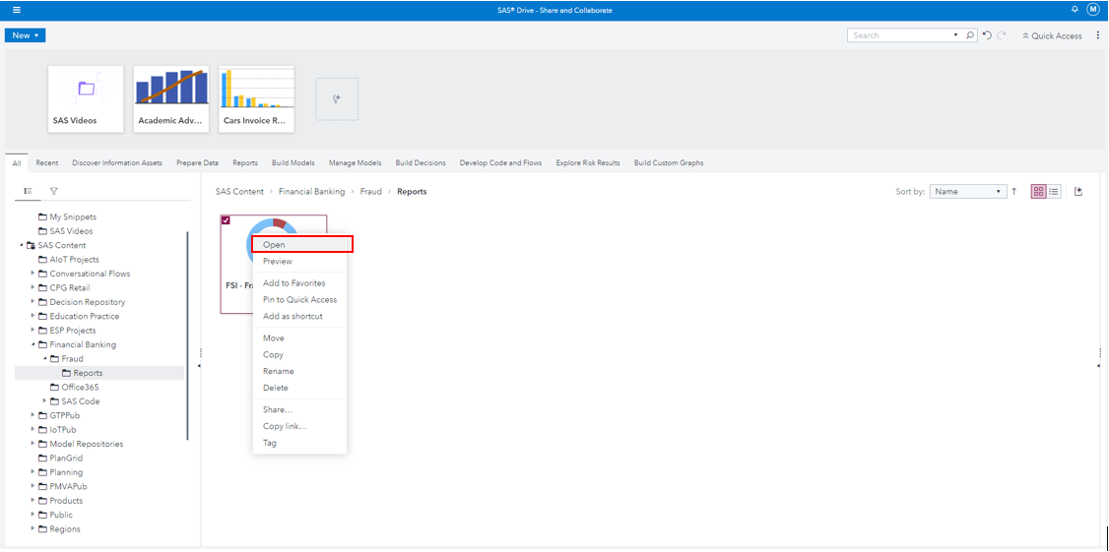

2. When the report has completed opening, click the pencil icon in the upper left corner to switch to Edit mode.



3. Then use the report's overflow in the upper right corner and select **Save as** from the menu. Save the report in your **My Folder** location. Name the report **New FSI - Fraud Dashboard Report** and click **Save.**

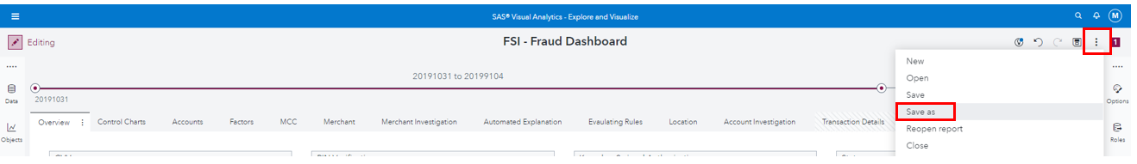

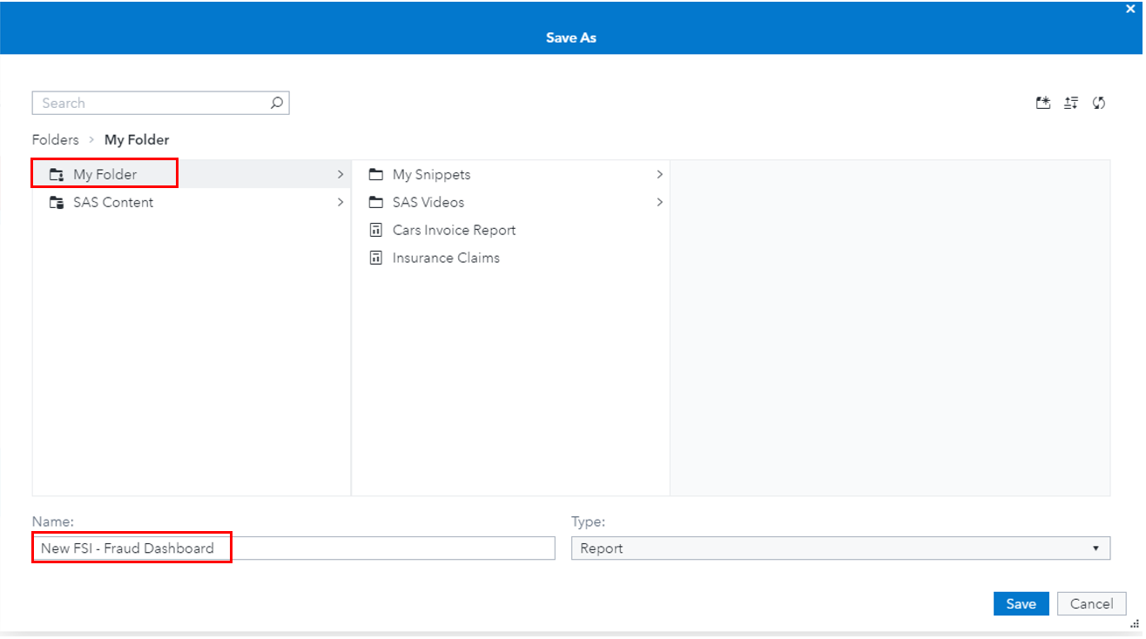

Navigate the report

1. You are now accessing your **New FSI - Fraud Dashboard Report** in **Edit** mode. Click the **Data** icon from the left side pane to display the **Data Pane**.

The name of the dataset should be **FRAUD_2019**

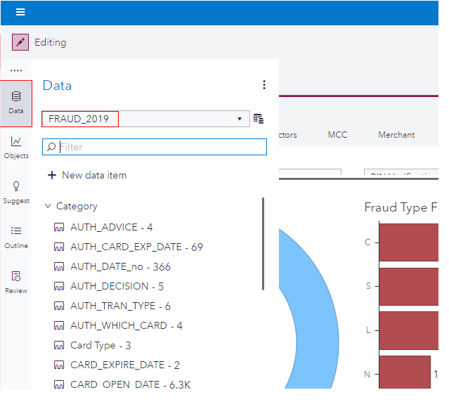

* 1. Click the **data source menu icon** to explore the options.

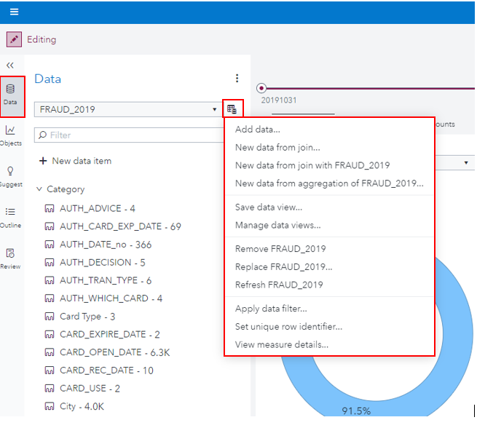

* 1. Click the New Data Item selection to view the possible data items - Hierarchy, Customer Category, Calculated item, Geography item, Parameter, Interaction effect, Spline effect, Partition

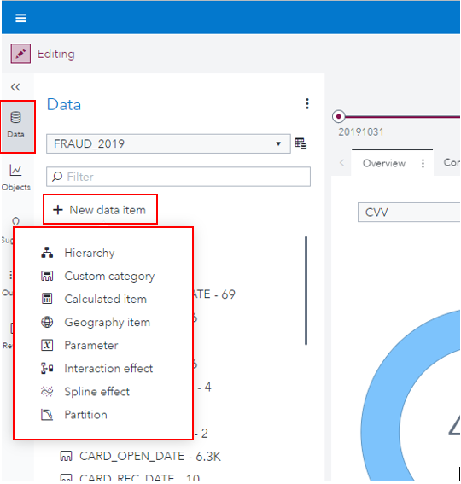

Close the **Data Pane** either by clicking outside the panel or by clicking the **Data** icon again.

4. Click the **Objects** icon from the left side pane and scroll to view the different types of report objects that are available. Notice from the list of objects that both **Visual Statistics** and **Visual Data Mining and Machine Learning** are included in this environment.

Use the **Objects Pane's** overflow menu and explore the different ways the objects can be arranged. Select **Collapse all** and then **Expand all** to see the functionality.

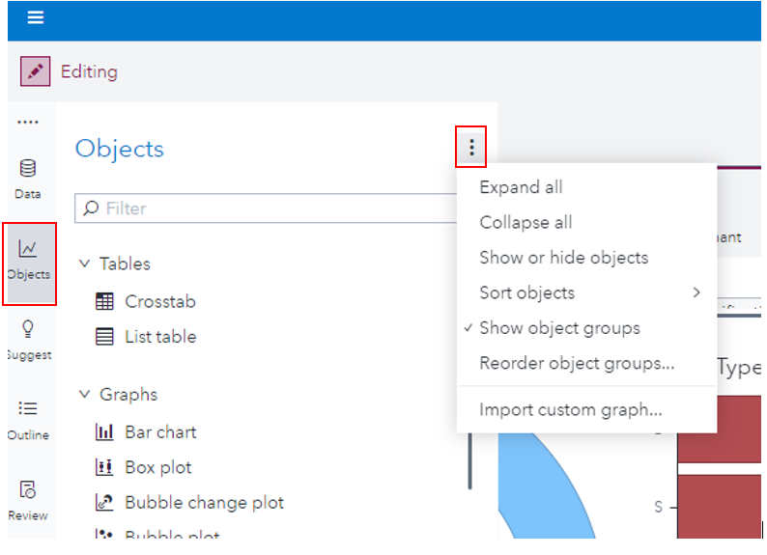

* 1. Click the **Suggest icon** from the left side pane - Here SAS has used machine learning to suggest objects based on the dataset.

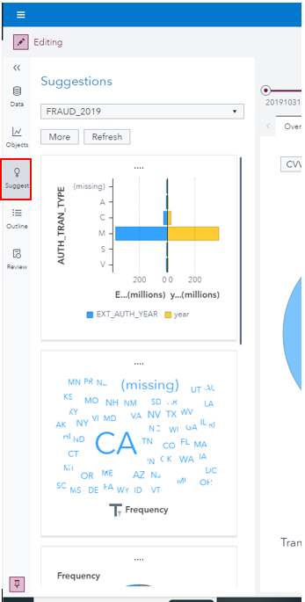

6. Next, click the **Outline** icon to open the **Outline Pane.**

Click the **Pin** icon in the lower left to pin the panel. When you pin the panel, both the panel and all report objects become visible.

From the **Outline Pane**, expand each page grouping to display all objects on each page. Click each page grouping in the outline then click on a few objects in each page. Notice that clicking a page item takes you to that page and activates the selected object.

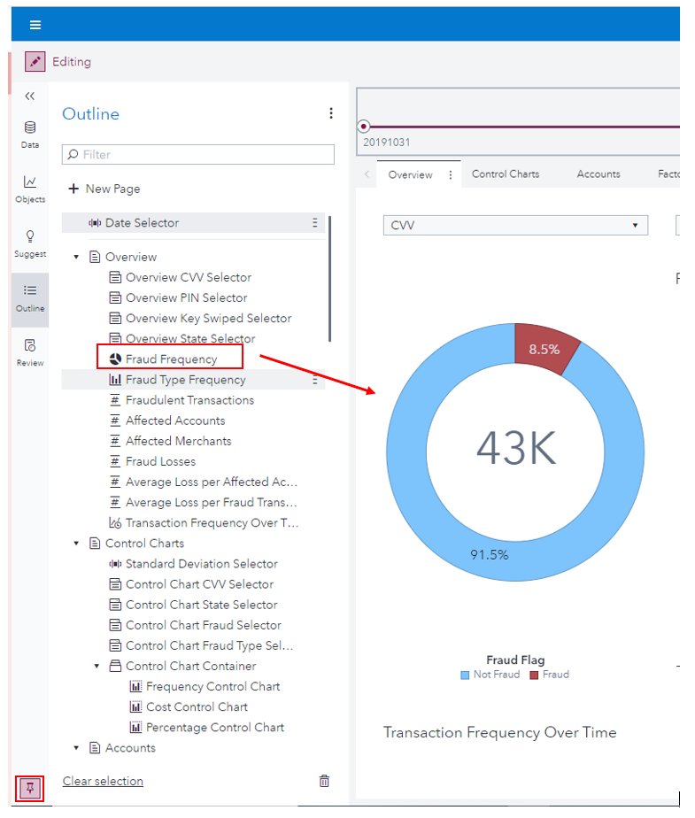

7. Click the **Account Investigation Map (1)** object from **Merchant Investigation** page using the **Outline Pane**. From the right panel, click the **Roles** icon to display the **Roles Pane** for the **Account Investigation Map (1)** object. Remember, use the **Pin** button to keep the pane open while viewing the entire report.

8. Use the **Outline Pane** from the left pane and the **Filters Pane** from the right pane to determine if any filters are assigned to the objects in the report. From the **Outline Pane**, click the **Fraudulent Transactions key value** from the **Overview page**. Make sure on the **Filters Pane** that **Fraud** is the only value selected.

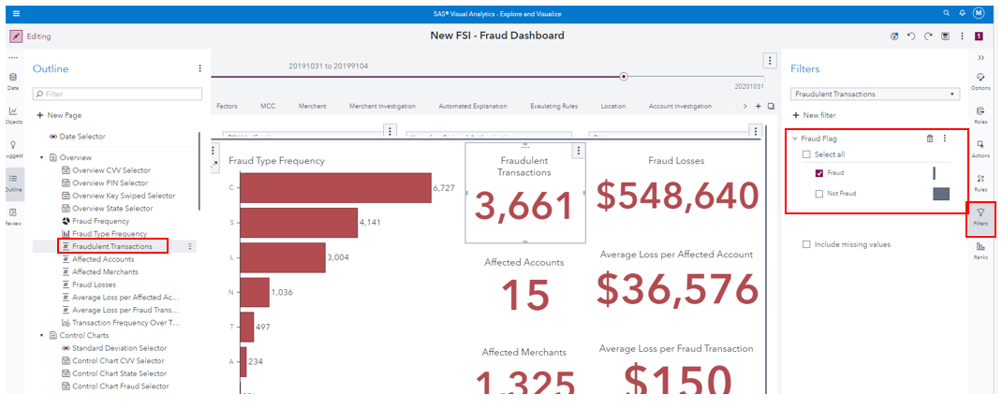

* 1. Use the **Outline Pane** to activate the **Fraud Type Frequency bar chart** object from the **Overview** page. Open the **Options Pane** from the right pane. Change the **Options** for the **Fraud Type Frequency bar chart** as follows:

* + Show data labels in red, with text size 8
  + Change the bar chart to vertical

* + Click on the Review Pane.

Use the report's overflow menu (vertical ellipsis) in the upper right of the report and select

**Save** to save your report.

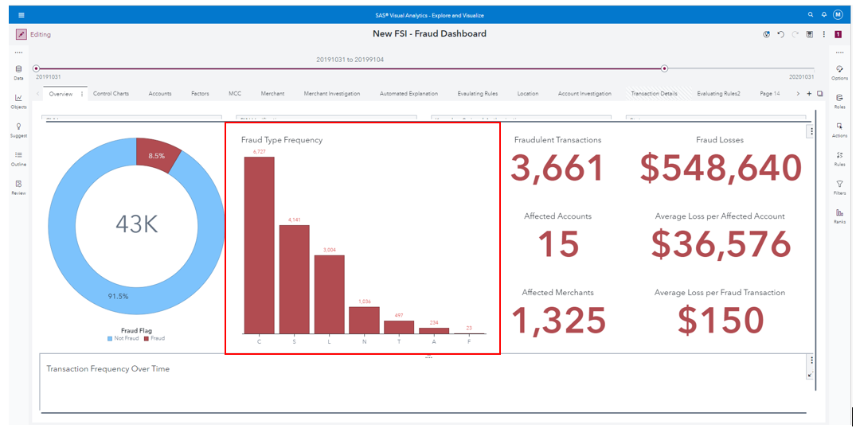

* 1. Use the side menu and return to **SAS Drive** by clicking **Share and Collaborate**. From the **All** tab, navigate to your **My Folder** directory and select your **New FSI - Fraud Dashboard Report**.

From the right pane, click through the **Details properties**.

Next, Open the report. Click on the pencil icon to switch to View mode.